JOY KARMOKAR

18-39263-3

COA(I) LAB TEST-2

INCLUDE "EMU8086.INC"

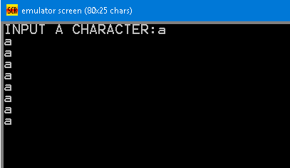.MODEL SMALL

.STACK 100H

.CODE

MAIN PROC

PRINT 'INPUT A CHARACTER:'

MOV AH,1

INT 21H

MOV BL,AL

MOV CX,8

TOP:

MOV DL,0DH

MOV AH,2

INT 21H

MOV DL,0AH

MOV AH,2

INT 21H

MOV DL,BL

MOV AH,2

INT 21H

LOOP TOP

LAST:

MOV AH,4CH

INT 21H

MAIN ENDP

ENDS MAIN